Запросы и отчеты к БД

1. Вывод всех записей

SELECT \*

FROM Request



1. Вывод всех выполненных заявок

SELECT \*

FROM Request

WHERE RequestStatusId=3



ViewRequest

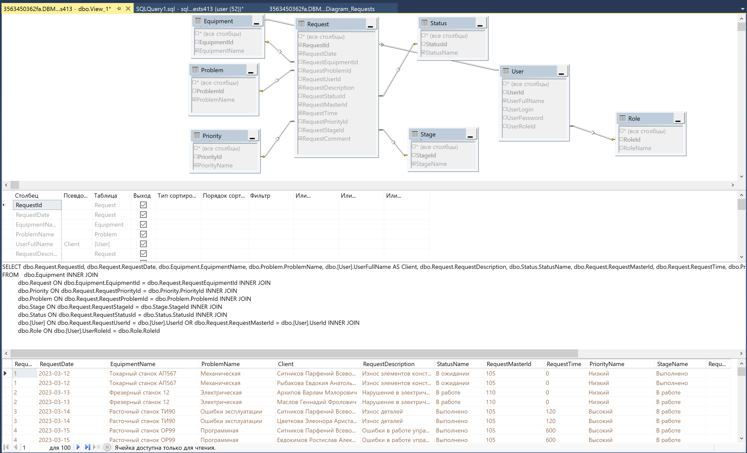

1. Среднее время выполненных заявок

select AVG(RequestTime)/60.0 as TimeAvg

from Request

where RequestStageId = 3

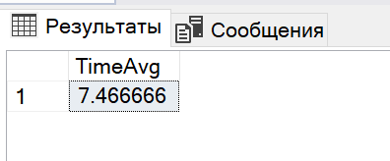

1. Создание хранимой процедуры на поиск выполненных заявок определенного мастера

CREATE PROCEDURE GetInfoRequestFromMaster

-- Add the parameters for the stored procedure here

@IdMaster int = 105

AS

BEGIN

-- Insert statements for procedure here

SELECT \*

from Request

Where RequestMasterId = @IdMaster and RequestStatusId = 3

END

GO

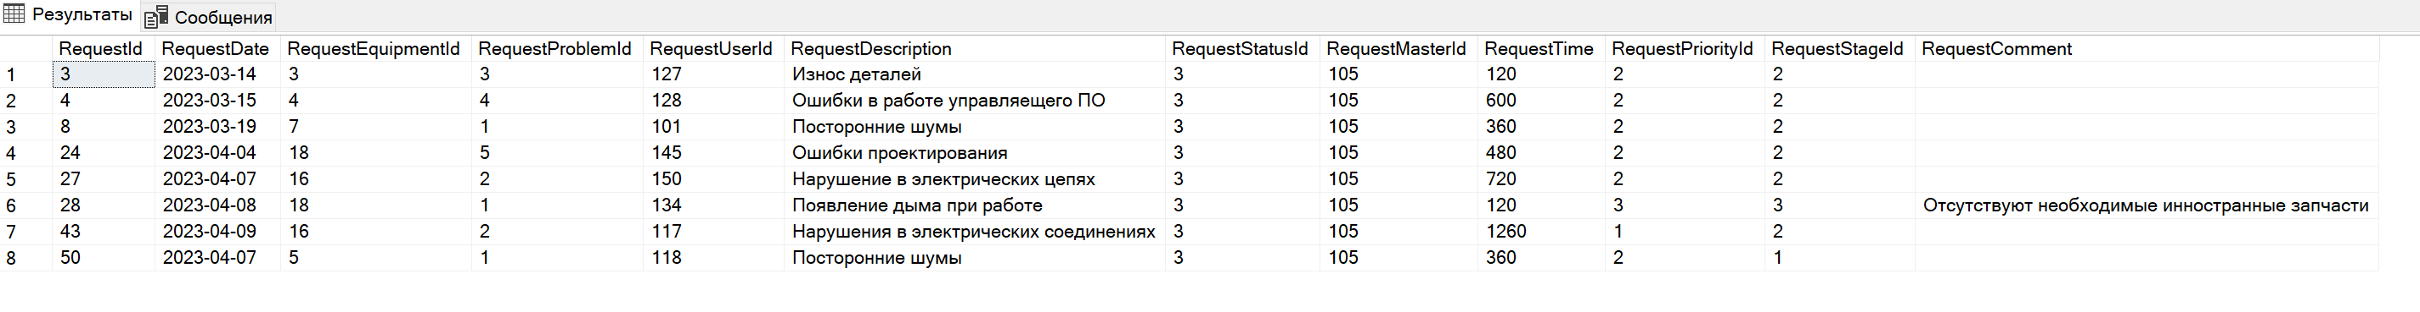

1. Вывод всех заявок с заменой ID

SELECT Request.RequestId, Equipment.EquipmentName, Request.RequestDate, Problem.ProblemName,

[User].UserFullName as Client, Request.RequestDescription, Status.StatusName, Request.RequestTime,

[User1].UserFullName as [Master],Priority.PriorityName, Stage.StageName, Request.RequestComment

FROM Equipment INNER JOIN

Request ON Equipment.EquipmentId = Request.RequestEquipmentId INNER JOIN

Priority ON Request.RequestPriorityId = Priority.PriorityId INNER JOIN

Problem ON Request.RequestProblemId = Problem.ProblemId INNER JOIN

Stage ON Request.RequestStageId = Stage.StageId INNER JOIN

Status ON Request.RequestStatusId = Status.StatusId INNER JOIN

[User] ON Request.RequestUserId = [User].UserId INNER JOIN

[User] as User1 ON Request.RequestMasterId = [User1].UserId



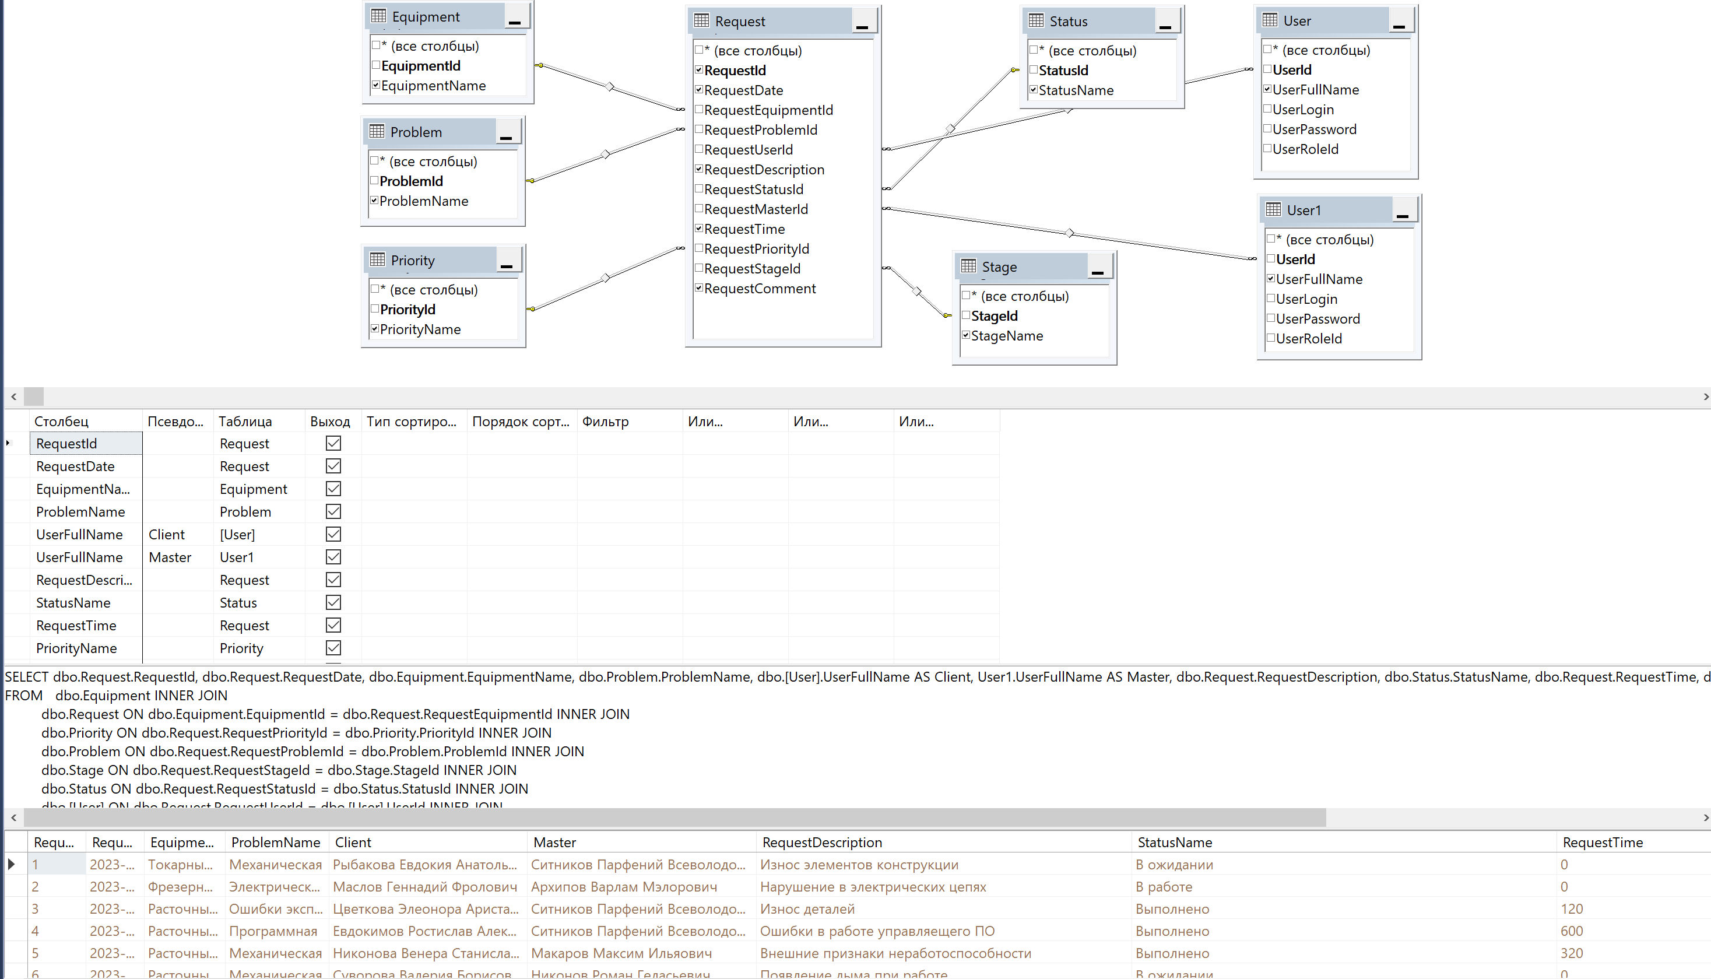

-- ================================================

-- Процедура выдает информацию о выполненных заявках

-- мастера по его ФИО

-- ================================================

CREATE PROCEDURE GetRequestsMasterName

@MasterName NVARCHAR(150)=NULL

AS

BEGIN

SELECT \*

FROM dbo.Request INNER JOIN

dbo.[User] ON dbo.Request.RequestMasterId = dbo.[User].UserId

WHERE dbo.[User].UserFullName=@MasterName AND dbo.Request.RequestStatusId=3

END

GO

--DROP PROC GetRequestsMasterName //Для удаление ранее созданной процедуры

EXEC GetRequestsMasterName N'Архипов Варлам Мэлорович'



-- ================================================

-- Процедура выдает информацию о заявках

-- мастера по его частичному ФИО

-- ================================================

CREATE PROCEDURE GetRequestsMasterShortName

@MasterName NVARCHAR(150)=NULL

AS

BEGIN

SELECT \*

FROM dbo.Request INNER JOIN

dbo.[User] ON dbo.Request.RequestMasterId = dbo.[User].UserId

WHERE dbo.[User].UserFullName LIKE ('%'+ @MasterName + '%')

END

GO

--DROP PROC GetRequestsMasterShortName

EXEC GetRequestsMasterShortName N'Архи'

